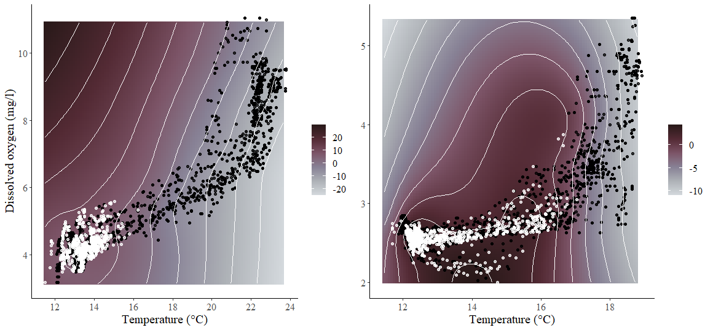
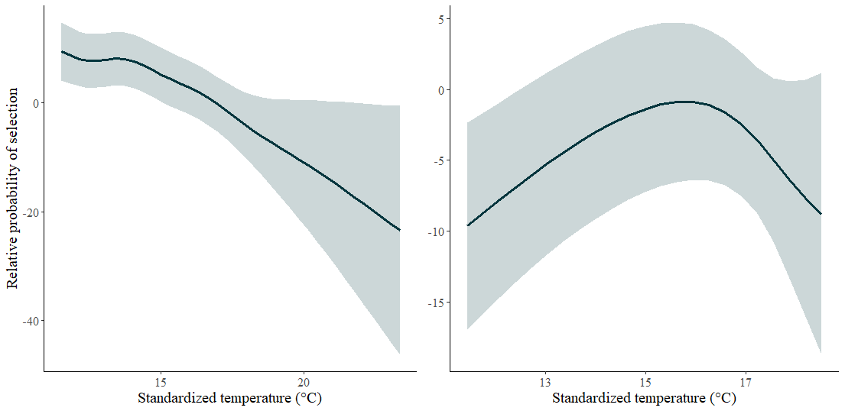
Blue ruin GAM results (with t:do interaction) – black points are available habitat, white points are fish, plots on left are during period of high DO/high temp (5-7pm), plots on right are period of low DO/low temp (5-7am)

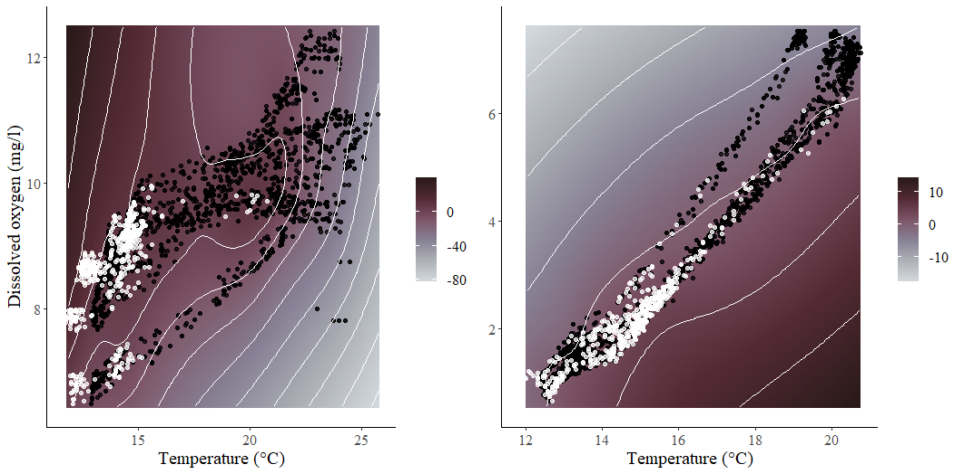
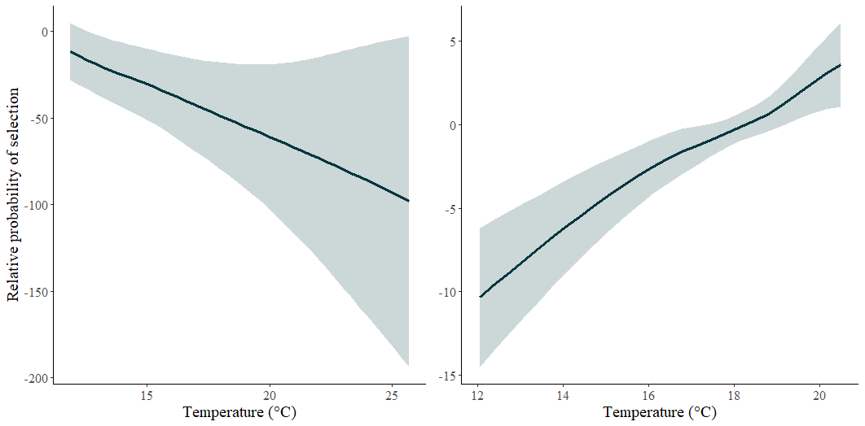

Norwood GAM results (with t:do interaction) – black points are available habitat, white points are fish, plots on left are during period of high DO/high temp (6-8pm), plots on right are period of low DO/low temp (6-8am)

